**PART 1**

**AN OVERVIEW OF THE TOPIC AND RELATED TECHNOLOGIES**

* 1. **Introduction to the Java Programming Language:**
     1. **The History of Java Programming Language:**

**Java** was first developed in the early 1990s by a team of engineers at Sun Microsystems, led by James Gosling. Initially, the project was called “Oak,” designed for interactive television, but it was too advanced for the time. In 1995, it was renamed “Java” and officially launched for web development, offering the key advantage of “write once, run anywhere” (WORA), thanks to the Java Virtual Machine (JVM).

**Java** quickly gained popularity for its portability, reliability, and security—making it a go-to language for web applications, enterprise software, and mobile apps (especially Android). Over the years, Java has continued to evolve, with major updates improving performance, syntax, and features. In 2010, Oracle acquired Sun Microsystems and took over Java’s development, ensuring its growth in both the open-source and enterprise world.

Today, Java remains one of the most widely used programming languages globally, trusted for building scalable, secure, and cross-platform applications.

* + 1. **What is Java?**

**Java** is a high-level, object-oriented programming language developed by Sun Microsystems in 1995. It allows code to run on any platform via the Java Virtual Machine (JVM), making it portable, secure, and widely used in web, mobile, and enterprise applications.

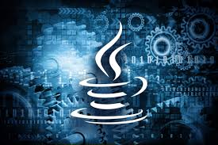

* + 1. **Key Features of Java Programming Language:**

**A. Platform Independence:**  
 **Java** programs are compiled into bytecode, which runs on the Java Virtual Machine (JVM). This means the same Java program can run on Windows, macOS, Linux, or any device with a JVM—no need to rewrite or recompile for each platform.

**B. Object-Oriented:**  
 **Java** is fully object-oriented, meaning everything is treated as an object. Concepts like **encapsulation** (hiding internal data), **inheritance** (reusing existing code), and **polymorphism** (one interface, many implementations) help organize and manage large programs more efficiently.

**C. Automatic Memory Management:**  
 **Java** uses a **garbage collector** to automatically handle memory allocation and deallocation. It frees up memory used by objects no longer in use, preventing memory leaks and reducing the chance of program crashes due to memory errors.

**D. Built-in Security:**  
 **Java** has several built-in security features, such as **bytecode verification**, **classloaders**, and a **security manager**. These work together to ensure code behaves safely, especially when running from untrusted sources like web browsers or networked environments.

**E. Multithreading Support:**  
 **Java** provides built-in support for **multithreading**, allowing multiple parts of a program to run concurrently. This makes it ideal for tasks like real-time data processing, animations, and responsive UI applications.

**F. Rich Standard Library:**  
 **Java** offers a massive collection of pre-built classes and packages (APIs) for things like **file handling**, **networking**, **data structures**, **database access**, and **graphical user interfaces (GUIs)**—saving time and effort for developers.

**G. Java Virtual Machine (JVM):** **The JVM** is the engine that runs Java bytecode. When you compile a Java program, it's converted into bytecode—not native machine code. The JVM interprets or compiles this bytecode into native code *at runtime*, depending on the device or OS. This is what gives Java its platform independence.

Beyond that, the JVM also:

* Manages memory through garbage collection.
* Provides built-in security and sandboxing.
* Handles exceptions and optimizes performance using Just-In-Time (JIT) compilation.

Thanks to the JVM, Java programs are portable, secure, and optimized across different systems—without needing to rewrite them.

* + 1. **Applications of Java:**

1. **Java and Web Development:**

**Java** is widely used to create **dynamic websites** and **web applications**. Frameworks like **Spring**, **Spring Boot**, and **JavaServer Faces (JSF)** make it easier to handle backend logic, databases, security, and APIs. Big websites and banking platforms often run on Java because of its speed and reliability.

**B. Java and Enterprise Systems:**

**Java** powers **large-scale enterprise applications** like **ERP** (Enterprise Resource Planning) and **CRM** (Customer Relationship Management). These systems handle thousands of users and massive data. Java EE (Jakarta EE) offers strong tools for scalability, transaction handling, and distributed computing—perfect for complex business apps.

**C. Java and Mobile Applications:**

**Java** is the **official language for Android development**. Using the **Android SDK**, developers write Java code to create mobile apps that run on millions of Android devices. It provides access to hardware, UI design, and other system services.

**D. Java and Desktop GUI Applications:**

**Java** supports desktop app development using **Swing** and **JavaFX**, which offer tools to build user interfaces (buttons, forms, tables, etc.). Though less common today for consumer apps, it's still used for internal business tools and educational software.

**E. Java and Embedded Systems & IoT:**

With **Java ME (Micro Edition)** and lightweight JVMs, **Java** can run on **small devices** like sensors, routers, smartcards, and appliances. It’s ideal for **IoT** (Internet of Things) projects where memory and power are limited, but secure and stable software is required.

**F. Java and Big Data & Scientific Computing:**

**Java** is used in **data-heavy environments** like **big data processing** with frameworks like **Apache Hadoop**, **Spark**, and **Storm**. It handles multithreading and large-scale data efficiently. Java is also used in scientific simulations and financial modeling.

**G. Java and Cloud Computing & Microservices:**

**Java** is great for **cloud-native** development. Tools like **Spring Boot** and **Micronaut** help developers build **microservices** that are small, independent, and scalable. These are often deployed in cloud platforms like AWS, Azure, and Google Cloud.

**H. Game Development:**

While not as popular as Unity or Unreal, **Java** is still used for 2D/3D games, especially in education or indie projects. Game engines like **LibGDX** use Java to create cross-platform games for desktop, web, and mobile. It's also used for server-side logic in multiplayer games.

* 1. **Introduction to the Spring Framework:**
     1. **Development History of Spring Framework:**

**The Spring Framework** began in October 2002 when Rod Johnson published Expert One‑on‑One J2EE Design and Development, proposing a lightweight, POJO‑based approach to J2EE development. In June 2003, the first public release—Spring 0.9—was made available under the Apache 2.0 license, laying the groundwork for its modular Inversion‑of‑Control container.

Spring 1.0 followed on March 24, 2004, introducing core features like dependency injection and Aspect‑Oriented Programming. Over the next several years, key milestones included Spring 2.0 (2006) with annotation support, Spring 3.0 (December 2009) adding RESTful web‑service capabilities, and Spring 4.0 (December 2013) bringing Java 8 compatibility and WebSocket integration.

On September 28, 2017, Spring 5.0 went GA, delivering reactive‑programming support via Spring WebFlux and deeper integration with JUnit 5 and Kotlin. Most recently, Spring 6.0 (November 22, 2022), Spring 6.1 (November 16, 2023), and Spring 6.2 (November 14, 2024) have moved the framework onto a Jakarta EE 9+ namespace and a Java 17+ baseline.

**∆:: The Timeline of Springboot’s evolution:**

**A. Early Origins (2002–2004):**  
 Rod Johnson’s *Expert One‑on‑One J2EE Design and Development* (October 1, 2002) laid out the concepts of a lightweight, POJO‑based container. He released the first source as Spring 0.9 under Apache 2.0 in June 2003, and Spring 1.0 followed on March 24, 2004, introducing core dependency‑injection (DI) and AOP support [Wikipedia](https://en.wikipedia.org/wiki/Spring_Framework).

**B. Maturation & Security (2005–2008):**  
 Spring 2.0 (October 2006) added annotation‑driven DI and expanded AOP; 2.5 (November 2007) improved data‐access and web‑MVC features [Wikipedia](https://en.wikipedia.org/wiki/Spring_Framework). In parallel, the Acegi Security project (late 2003) became Spring Security, with its first 2.0.0 release in April 2008, offering integrated authentication/authorization for enterprise apps [Wikipedia](https://en.wikipedia.org/wiki/Spring_Security?utm_source=chatgpt.com)[Home](https://docs.spring.io/spring-security/site/docs/3.0.x/reference/introduction.html?utm_source=chatgpt.com).

**C. Enterprise Growth & Corporate Backing (2009–2013):**  
 VMware acquired SpringSource in August 2009, cementing commercial support [Wikipedia](https://en.wikipedia.org/wiki/Spring_%28company%29?utm_source=chatgpt.com). Spring 3.0 (December 2009) introduced REST‑style web services; 3.1 (December 2011) added caching and scheduling; and 3.2 (November 2013) refined Java 8 compatibility. Meanwhile, Spring Data (2011) extended Spring’s reach to NoSQL stores like MongoDB and Redis [SpringOne](https://springone.io/history-of-spring?utm_source=chatgpt.com).

**D. Spring Boot & the Reactive/Cloud Era (2014–Present):**  
 Pivotal launched Spring Boot 1.0 GA on April 1, 2014 to simplify project bootstrap and auto‑configuration. Boot 2.0 arrived in March 2018 and Boot 3.0 in November 2022 (Jakarta EE 9+ baseline, GraalVM support). Spring Framework 5.0 (September 28, 2017) added reactive‑programming via WebFlux, and Spring 6.x (November 2022, 2023, 2024) moved fully to Jakarta EE 9+ and Java 17+ [Wikipedia](https://en.wikipedia.org/wiki/Spring_Framework).

Across these phases, Spring grew from a DI/AOP container to a full‑featured ecosystem—spanning security, data, microservices, cloud‑native, and reactive frameworks—now stewarded under VMware Tanzu’s open‑source umbrella.

* + 1. **Modules in the Spring Framework:**

**The Spring Framework** includes features organized into about 20 modules. These modules are grouped into Core Container, Data Access/Integration, Web, AOP (Aspect Oriented Programming), Instrumentation, Messaging, and Test, as shown in the following diagram.

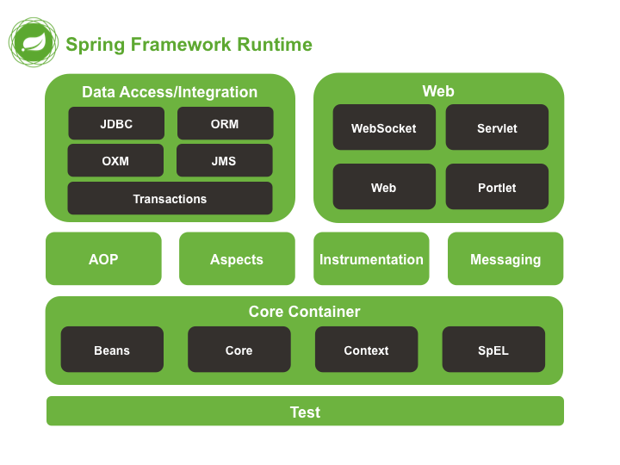

**A. Core Module:**  
 The Core module provides the fundamental features of the Spring Framework, particularly the concepts of Inversion of Control (IoC) and Dependency Injection (DI). It lays the foundation for creating and managing beans—the objects in your application—by supplying the BeanFactory interface, which is responsible for instantiating and wiring components together. It also offers essential utilities like resource loading and type conversion, which are heavily used across other Spring modules.

**B. Beans Module:**  
 The Beans module is centered around the configuration, creation, and management of application beans. It supports defining beans through XML files, annotations, or Java-based configuration. This module handles the full lifecycle of each bean, including initialization and destruction, while also allowing for different scopes such as singleton, prototype, or session-based. It is one of the most crucial modules for enabling modular, flexible application design.

**C. Context Module:**  
 Building on the Core and Beans modules, the Context module introduces a more advanced ApplicationContext interface, which offers features like internationalization (i18n), event publication, and application-layer specific functionalities. It also provides support for annotation-driven dependency injection (e.g., @Autowired) and configuration scanning (@ComponentScan). The context module is what allows Spring to act as a complete framework for building loosely coupled enterprise applications.

**D. SpEL (Spring Expression Language):**  
 The SpEL module adds powerful expression language support to Spring. It allows developers to embed expressions directly into configuration files or annotations, enabling dynamic property evaluation, method calls, conditional logic, and access to collection data. SpEL is especially useful in advanced bean definitions and is heavily used in Spring Security, Spring Data, and other frameworks built on top of Spring.

* + 1. **Projects in the Spring Framework:**

**A. Spring MVC:**  
 A web‑framework module built on the Core Container that implements the Model‑View‑Controller pattern. It handles HTTP requests, maps them to controller methods, and renders views (JSP, Thymeleaf, etc.), making it easy to build flexible, testable web applications.

**B. Spring Data:**  
 Provides a unified, repository‑style abstraction over various data stores (JPA, MongoDB, Redis, Elasticsearch, etc.). It auto‑generates queries from method names and integrates with Spring’s transaction and mapping facilities, drastically reducing boilerplate for CRUD and paging operations.

**C. Spring Security:**  
 A comprehensive, customizable authentication and authorization framework. It plugs into Spring MVC (and other HTTP endpoints) to secure URLs, method calls, and web services, offering features like form‑login, OAuth2, JWT, CSRF protection, and fine‑grained access control.

**D. Spring Boot:**  
 Opinionated “convention‑over‑configuration” layer that accelerates Spring application development via auto‑configuration, starter dependencies, and embedded servers (Tomcat, Jetty). It lets you get production‑ready apps up and running with minimal setup.

**E. Spring Batch:**  
 A lightweight batch‑processing framework designed for robust, high‑volume jobs. It provides reusable patterns for chunk‑oriented processing, transaction management, restartability, skip‑logic, and job monitoring—ideal for ETL, reports, or large data imports/exports.

**F. Spring Integration:**  
 Offers an extension of Spring’s programming model to support Enterprise Integration Patterns (EIP). It supplies adapters and channels for messaging, file‑transfer, web services, and more, enabling you to build event‑driven, message‑based architectures within the Spring container.

**G. Spring XD:**  
 An older, now‑superseded project for big‑data ingestion and real‑time stream/batch processing. It combined Spring Integration and Spring Batch under a unified runtime; its features have since been rolled into Spring Cloud Data Flow.

**H. Spring Social:**  
 A module for integrating OAuth‑based “social” logins and APIs (Facebook, Twitter, LinkedIn). It simplifies connecting your application to social providers for user authentication or data access, managing tokens, and binding API clients to your Spring beans.

* 1. **Introduction to Maven:**
     1. **What is Maven?**
* **Apache Maven** is a build‑automation and project‑management tool for Java (and other JVM) projects.

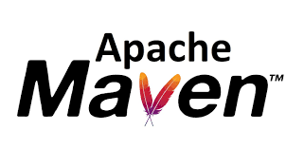

* It uses a **Project Object Model** (POM) file (pom.xml) as the single source of truth for build configuration.
* **Maven** standardizes the build process through a well‑defined **lifecycle** of phases and goals.
* It handles **dependency management**, automatically downloading required libraries into a local repository.
* The system is **extensible** via plugins and **configurable** through build profiles for different environments.

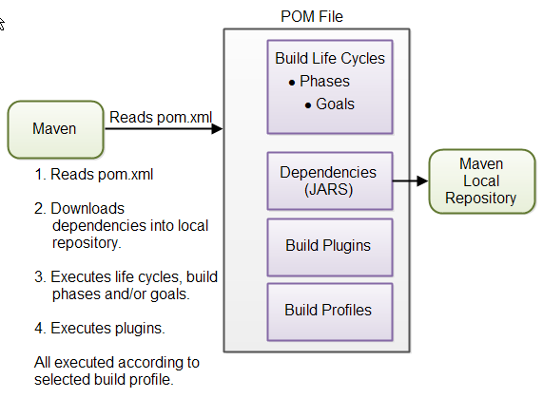

* + 1. **How Does Maven Work?**

|  |  |
| --- | --- |
| **Criteria** | **Steps** |
| **Read POM** | parses pom.xml to discover project settings, dependencies, plugins, lifecycles, and profiles. |
| **Resolve Dependencies** | downloads declared JARs (and their transitive dependencies) into your local Maven repository. |
| **Execute Lifecycle** | runs the standard build lifecycle (e.g., validate → compile → test → package → install → deploy). |
| **Run Plugins** | invokes any configured build plugins (for code generation, packaging, deployment, etc.), all scoped by the active build profile. |

* + 1. **Why Do We Need Maven?**
* Maven helps standardize the build process by managing tasks like compiling, testing, packaging, and deploying through a defined lifecycle. It simplifies dependency management via the pom.xml file and ensures consistent project structure. With powerful plugins and support for multi-module projects, it streamlines complex Java applications efficiently.
* For developers, Maven improves teamwork with a predictable layout and easy integration into IDEs and CI/CD tools like Jenkins. It reduces manual effort, minimizes errors, and speeds up project setup—making collaboration and delivery smoother and more reliable.
  1. **Introduction to MySQL:**
     1. **Overview of MySQL:**

**MySQL** is an open‑source, high‑performance relational database using SQL, originally developed in 1995 and now maintained by Oracle. It’s a core part of the LAMP stack and offers a pluggable storage‑engine architecture to meet diverse workload needs.

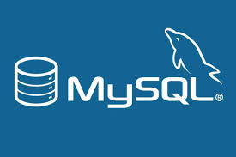

**∆:: Advantages of MySQL:**

* Open‑source and freely available (with optional commercial editions)
* Cross‑platform support (Linux, Windows, macOS)
* High performance and scalability for small to large datasets
* Flexible storage engines (InnoDB, MyISAM, etc.)
* ACID‑compliant transactions and reliable crash recovery
* Built‑in replication, clustering, and partitioning for high availability
* Strong community ecosystem plus enterprise support
* Rich tooling and integrations (GUI clients, connectors, monitoring)
* Robust security features (user authentication, SSL/TLS, encryption)
  + 1. **Introduction to MySQL Workbench:**

**MySQL Workbench** is the official, cross‑platform graphical tool for designing, developing, and administering MySQL databases. It brings a unified visual interface to everything from data modeling and SQL development to server configuration, user administration, and performance tuning—making complex tasks intuitive and efficient.

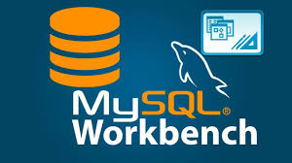

**∆:: Key Components & Features:**

|  |  |
| --- | --- |
| **Criteria** | **Key Components Purpose** |
| **SQL Editor** | Write, execute, and debug queries with syntax highlighting, auto‑completion, and visual explain plans |
| **Data Modeling** | Create and reverse‑engineer ER diagrams, manage schemas, and generate DDL scripts. |
| **Server Administration** | Configure server settings, manage users/privileges, monitor status variables, and view logs. |
| **Migration Wizard** | Automate migration from other RDBMS (Oracle, SQL Server, PostgreSQL) into MySQL. |
| **Performance Dashboard** | Track real‑time performance metrics, spot bottlenecks, and tune queries using visual dashboards. |
| **Backup & Recovery** | Schedule and execute logical backups, restores, and schema synchronizations. |
| **Visual Tools** | Manage indexes, foreign keys, triggers, and stored routines via point‑and‑click interfaces. |

With MySQL Workbench, both developers and DBAs gain a single, powerful environment to model data, build queries, and keep their MySQL servers running smoothly.

* 1. **Introduction to ReactJS:**
     1. **What is ReactJS?**

**ReactJS** is a lightweight JavaScript library (by Facebook) for building user interfaces using reusable, component‑based architecture. It lets you describe your UI in a **declarative** way and uses a **virtual DOM** to update only the parts of the page that change—making your apps fast, maintainable, and easy to reason about.

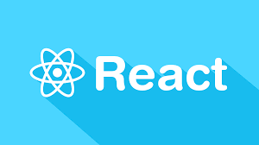

* + 1. **Advantages and Disadvantages of ReactJS:**
       1. **Advantages:**

• ReactJS lets you build UI from small, reusable pieces (components).

• ReactJS updates the page quickly by only changing what’s needed.

• ReactJS has a big community and lots of ready‑made tools.

• ReactJS uses JSX so you write HTML‑like code right in JavaScript.

* + - 1. **Disadvantages:**

• ReactJS only handles the view layer—you need other tools for state, routing, etc.

• ReactJS requires a build setup (Babel, Webpack) which can be tricky.

• ReactJS frequent updates mean you have to keep learning new patterns.

• ReactJS purely client‑side rendering can hurt SEO unless you add server‑side rendering.

* + 1. **Main Components of ReactJS:**

|  |  |
| --- | --- |
| **Criteria** | **Main Components Purpose** |
| **JSX** | A syntax extension that lets you write HTML‑like code in JavaScript for defining UI structure. |
| **Components** | Reusable, self‑contained pieces of UI. Can be functional (with Hooks) or class‑based. |
| **Props** | Read‑only inputs passed from parent to child components for configurability and data flow. |
| **State** | Internal, mutable data managed within a component that drives its rendering and behavior. |
| **Lifecycle Methods** | (Class components) Hooks like componentDidMount and componentWillUnmount that run at specific points in a component’s existence. |
| **Hooks** | Functions like useState and useEffect that let functional components manage state and side effects. |
| **Virtual DOM** | An in‑memory representation of the UI that React diffs against the real DOM to update only what’s changed. |

* + 1. **Core Features of ReactJS:**

|  |  |
| --- | --- |
| **Criteria** | **Core Features Purpose** |
| **Declarative Views** | Describe what the UI should look like for a given state, and React handles updating the DOM. |
| **Component-Based Architecture** | Build UIs from small, reusable, self-contained components. |
| **JSX Syntax** | Blend HTML‑like markup with JavaScript to define component structure clearly. |
| **Virtual DOM** | React keeps a lightweight copy of the DOM in memory and updates only what’s changed, for fast rendering. |
| **One‑Way Data Binding** | Data flows down from parent to child components via props, making state changes predictable. |
| **ks** | Manage component setup, updates, and cleanup through class methods or functional Hooks (useState, useEffect). |
| **Context API** | Share data across multiple components without passing props through every level, simplifying global state. |

* 1. **Introduction to IoT Sensors:**
     1. **What are IoT Sensors?**

**IoT (Internet of Things) sensors** are smart devices that detect and measure physical, environmental, or chemical conditions and convert these readings into digital signals. Connected to networks via wired or wireless technologies (e.g., Wi-Fi, Bluetooth, LoRaWAN), they enable real-time data collection and transmission to cloud platforms or local gateways for analysis and decision-making.

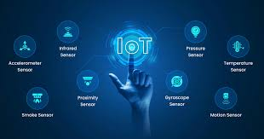

* + 1. **History and Development of IoT Sensor Technology:**

The concept of connected devices dates back to the early 1980s, with the first known IoT device being a Coca-Cola vending machine at Carnegie Mellon University that reported its inventory status online. The term “Internet of Things” was coined in 1999 by Kevin Ashton during his work on RFID technology at Procter & Gamble.

Through the 2000s, advances in wireless communication, cloud computing, and microelectronics spurred the development of more compact and affordable sensors. The rise of IPv6, low-power wireless technologies (like Zigbee and LoRa), and platforms for edge computing further enabled widespread IoT deployment.

In the 2010s, IoT ecosystems flourished with the proliferation of smartphones and cloud services. Sensor miniaturization and integration with AI opened up powerful new applications—from smart homes to precision agriculture and environmental monitoring. Today, IoT sensors are pivotal in shaping the digital transformation across industries, with ongoing innovation in nanotechnology, AI, and 5G further expanding their potential.

* + 1. **Types of IoT Sensors:**

|  |  |
| --- | --- |
| **Criteria** | **Type Purpose** |
| **Environmental Sensors** | Temperature, humidity, air quality (e.g., PM2.5, CO₂), pressure. |
| **Motion & Position Sensors** | Accelerometers, gyroscopes, magnetometers, GPS modules. |
| **Optical Sensors** | Light intensity (LDR), proximity, infrared. |
| **Acoustic Sensors** | Microphones, ultrasonic distance sensors. |
| **Chemical & Gas Sensors** | VOC detectors, CO, O₃, NO₂, methane. |
| **Biosensors** | Heart-rate, glucose monitors, wearable health trackers. |

* + 1. **Advantages and Limitations of IoT Sensors:**
       1. **Advantages:**

|  |  |
| --- | --- |
| **Criteria** | **Advantages** |
| **Real-Time Monitoring** | Enables continuous data collection and instant responses. |
| **Improved Efficiency** | Supports automation and predictive maintenance, reducing costs. |
| **Scalability** | Easily deployable across various environments. |
| **Data-Driven Decisions** | Provides insights that inform better management and planning. |

* + - 1. **Limitations:**

|  |  |
| --- | --- |
| **Criteria** | **Limitations** |
| **Security Risks** | Vulnerable to hacking and data breaches. |
| **Power Constraints** | Many sensors rely on limited battery power. |
| **Connectivity Dependence** | Performance may degrade in areas with poor network coverage. |
| **Data Overload** | Large volumes of raw data may require complex processing and storage solutions. |

* + 1. **Applications of IoT Sensors in Real Life:**

|  |  |
| --- | --- |
| **Criteria** | **Applications** |
| **Smart Cities** | Air-quality monitoring, traffic management, waste collection. |
| **Industry 4.0** | Predictive maintenance, asset tracking, process control. |
| **Healthcare** | Remote patient monitoring, smart wearables. |
| **Agriculture** | Soil moisture, nutrient levels, weather stations. |

* 1. **Introduction to Artificial Intelligence (AI) and Deep Learning:**
     1. **What is Artificial Intelligence (AI)?**

**Artificial Intelligence (AI)** refers to the simulation of human intelligence in machines that can learn, reason, and make decisions. In the context of IoT, AI enhances sensor data processing, enabling systems to detect patterns, predict events, and automate actions intelligently.

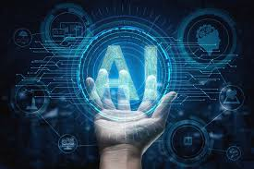

* + 1. **History and Development of AI:**

**Artificial Intelligence (AI**) emerged in the mid‑20th century, rooted in Alan Turing’s 1950 proposal of the "Turing Test" and formalized at the 1956 Dartmouth Conference led by **John McCarthy**. Early AI research focused on symbolic reasoning and expert systems in the 1960s and 1970s, but progress slowed during the "AI winters" of the 1980s due to computational and funding limitations. The revival in the 1990s brought statistical machine learning techniques, while the landmark 2006 work by Geoffrey Hinton sparked the modern deep learning revolution. Advances in GPU computing, algorithm design, and large datasets led to breakthroughs in neural network architectures—culminating in successes like AlexNet (2012) in computer vision. Today, AI and deep learning power applications across natural language processing, computer vision, and autonomous systems, driving innovation in IoT, healthcare, transportation, and beyond.

* + 1. **What is Deep Learning?**

**Deep Learning** is a specialized branch of AI based on neural networks with multiple layers (deep neural networks). It excels at handling large datasets and identifying complex patterns, especially in unstructured data like images or sensor signals.

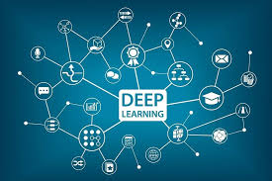

* + 1. **Differences Between AI, Machine Learning, and Deep Learning:**

While **Artificial Intelligence (AI)** encompasses the broad field of creating machines capable of human-like decision-making and problem-solving.

**Machine Learning (ML)** is a subset of AI focused on algorithms that improve through experience. ML techniques use statistical methods to enable computers to learn from data without explicit programming.

**Deep Learning (DL)** is a further subset of ML employing multi-layered neural networks to automatically learn hierarchical representations from large datasets, excelling in tasks like image and speech recognition where features are complex and unstructured.

|  |  |  |  |
| --- | --- | --- | --- |
| **Criteria** | **AI** | **Machine Learning** | **Deep Learning** |
| **Scope** | Encompasses all aspects of simulating intelligence and reasoning. | Focuses on algorithms that learn from data without explicit programming. | Utilizes multi-layered neural networks to learn hierarchical representations. |
| **Data Dependency** | May use rule-based logic or limited data. | Requires structured datasets for training. | Thrives on massive, unstructured datasets for feature learning. |
| **Complexity & Computing Power** | Can run on modest hardware; varies by algorithm. | Moderate computing resources; depends on model complexity. | Demands significant GPU/TPU resources for training deep networks. |
| **Feature Engineering** | Involves human-defined rules or logic. | Requires manual feature extraction and selection. | Automatically extracts features through its hidden layers. |
| **Applications** | Expert systems, robotics, planning, reasoning. | Regression, classification, clustering, and predictive modeling. | Computer vision, natural language processing, speech recognition, and autonomous systems. |

* + 1. **Core Features of Deep Learning:**

|  |  |
| --- | --- |
| **Criteria** | **Core Features Purpose** |
| **Hierarchical Representation Learning** | Deep networks learn layered, abstract features directly from raw data. |
| **Automatic Feature Extraction** | Eliminates manual engineering by discovering relevant patterns during training |
| **Non-linear Transformations** | Activation functions enable modeling complex relationships |
| **End-to-End Learning** | Direct mapping from input to output enhances performance and simplicity |
| **High Scalability** | Leverages parallel hardware (GPUs/TPUs) and large datasets to train massive models |
| **Transfer Learning** | Reuses pre-trained models to adapt to new tasks with limited data |
| **Regularization Techniques** | Dropout, batch normalization, and early stopping prevent overfitting |

* + 1. **Applications of AI and Deep Learning in Real Life:**

|  |  |
| --- | --- |
| **Criteria** | **Application Purpose** |
| **Healthcare Diagnostics** | AI-driven image analysis for early disease detection and personalized treatment plans. |
| **Autonomous Vehicles** | Deep learning models for object detection, lane recognition, and decision-making in self-driving cars. |
| **Smart Assistants** | Natural language understanding and speech recognition powering virtual assistants like Siri and Alexa. |
| **Predictive Maintenance** | Analyzing IoT sensor data to forecast equipment failures and schedule repairs proactively. |
| **Environmental Monitoring** | AI-enhanced analysis of sensor networks for accurate air quality forecasting and pollution hotspot identification. |
| **Recommendation Systems** | Personalized product and content suggestions in e-commerce and streaming platforms based on user behavior. |
| **Fraud Detection** | Real-time anomaly detection in financial transactions and cybersecurity applications. |
| **Language Translation** | Neural machine translation enabling accurate, context-aware multilingual communication. |